**Lab Sheet 4**

IT24100885

Perera A.J.M.P.

1.

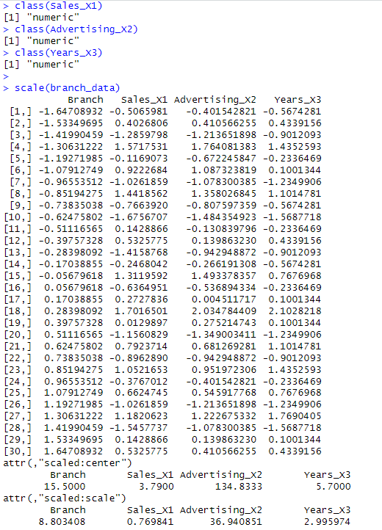2.

3.

4.

5.